SecturaFAB Version 2023.04.28.2 Release Notes
What's NEW - May 2023
- New End User License Agreement (EULA)
- Dashboards are back!
- Machine File Interface
- Vendor Dropdown Fix

1. New End User License Agreement (EULA)
After log-in all users will see the screen below pop up and are required to accept the EULA. Once accepted you can always view or download the EULA by navigating to the Setup page under Users & Permissions -> Licensing. If you have any questions regarding this document, please contact our Customer Success team at help@secturasoft.com.

Note: You must scroll to the bottom of the page to enable the acceptance check box.

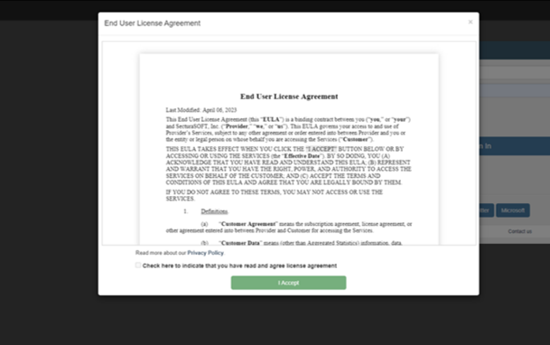

2. Dashboards are back!

Dashboards were temporarily disabled while implementing changes to improve performance. Dashboards have now been re-enabled and are again available for use. Visit your dashboard page for a helpful overview of metrics like total sales by sales rep, sales by material and more!

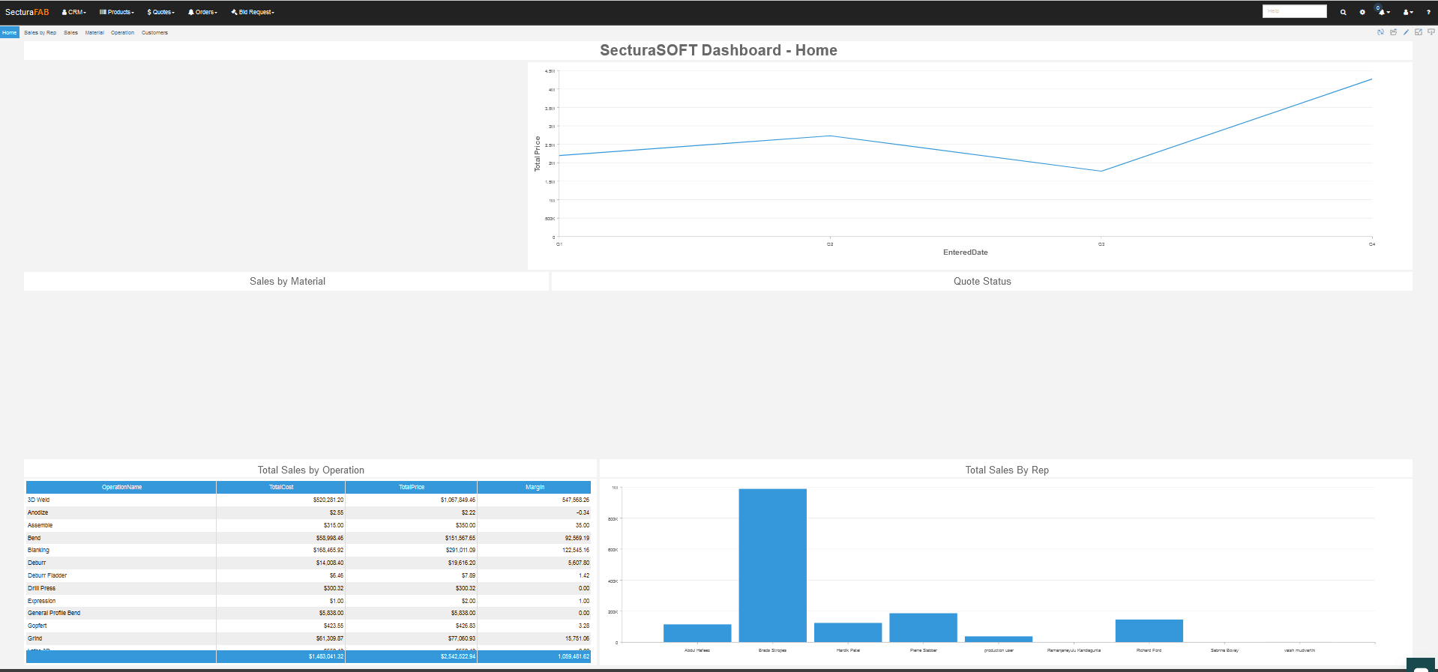

3. Machine File Interface
The new SecturaFAB machine file interface allows you to view, modify & delete machine files from within the software, where before this was not possible. All changes can now be done within SecturaFAB so you can avoid going to the XML file for changes and have confidence and visibility over your machine file management
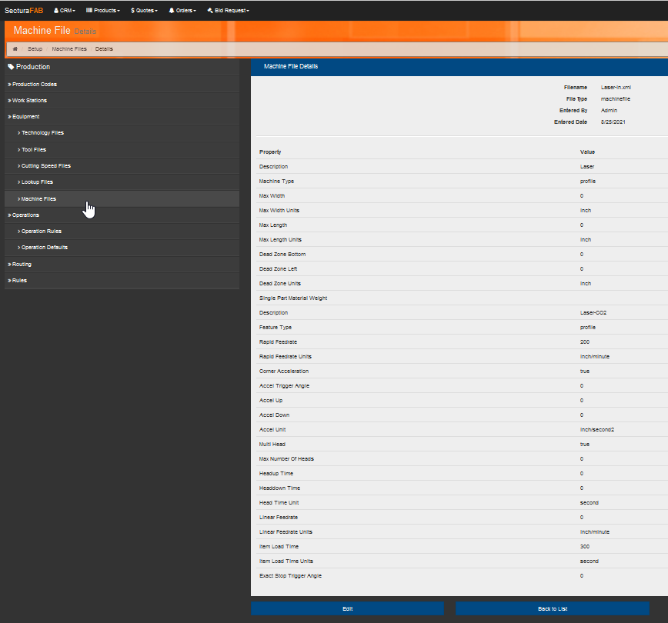

4. Vendor Drop Down Fix

An issue with the vendor dropdown not populating in some cases was resolved. These dropdowns are now updated to work with the latest pagination enhancements for faster loading.

