Release Notes: SecturaFAB Version 2023.06.13.4

On this page:
- SecturaFAB - What's NEW - April 2023
  - Introduction
  - Enhanced Accuracy Quoting Linear Items Imported from STEP
  - Improved SKU Filters
  - Bug Fix: Copy Quote
  - Component Unit Costs Greater Than $999
  - Populating Tool Selection Dropdown Menu when Adding Operations
  - Conclusion

SecturaFAB - What's NEW - June 2023
Introduction: We are excited to announce the release of SecturaFAB Version 2023.06.13.4! This latest version brings several enhancements, and bug fixes to improve your quoting and estimating workflows. We believe that these enhancements will significantly improve the accuracy and efficiency of your quoting and estimating processes.
Read on to explore what's new:
- Enhanced Accuracy Quoting Linear Items Imported from STEP

  - Our development team has implemented advanced algorithms and parsing techniques specifically tailored to handle linear STEP files. As a result, the software now achieves greater accuracy in reading and interpreting dimensions, measurements, and other crucial data from these files. This enhancement ensures that quotes and estimates generated from linear STEP files are more precise and reliable than ever before.

  - 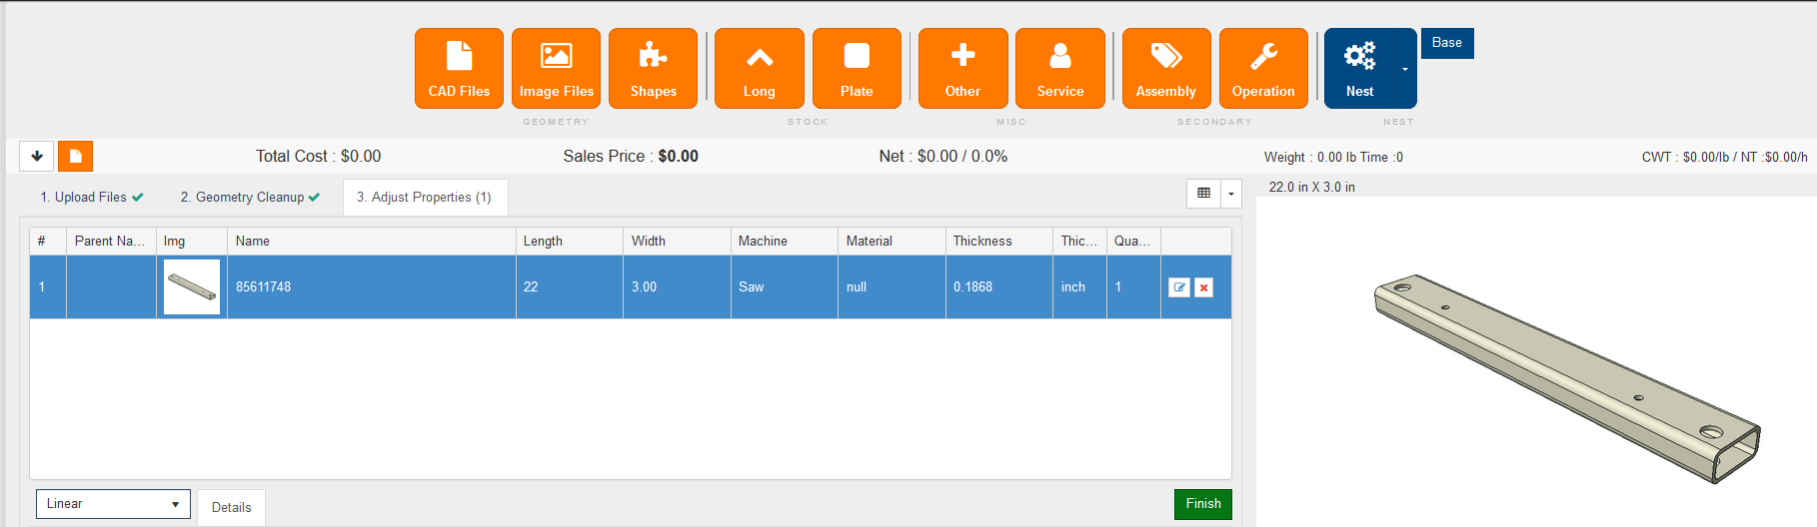

- Improved SKU Filtering

  - Select Product windows will now display all relevant product and SKU data and not filter from parameters outside of the window. Previously this window would filter based off the length of the linear item. Additionally select cases where foreign SKU data would be visible in your product list were resolved, robust data isolation methods were put in place, ensuring that each tenant's SKU information remains completely confidential and inaccessible to unauthorized users.

  - 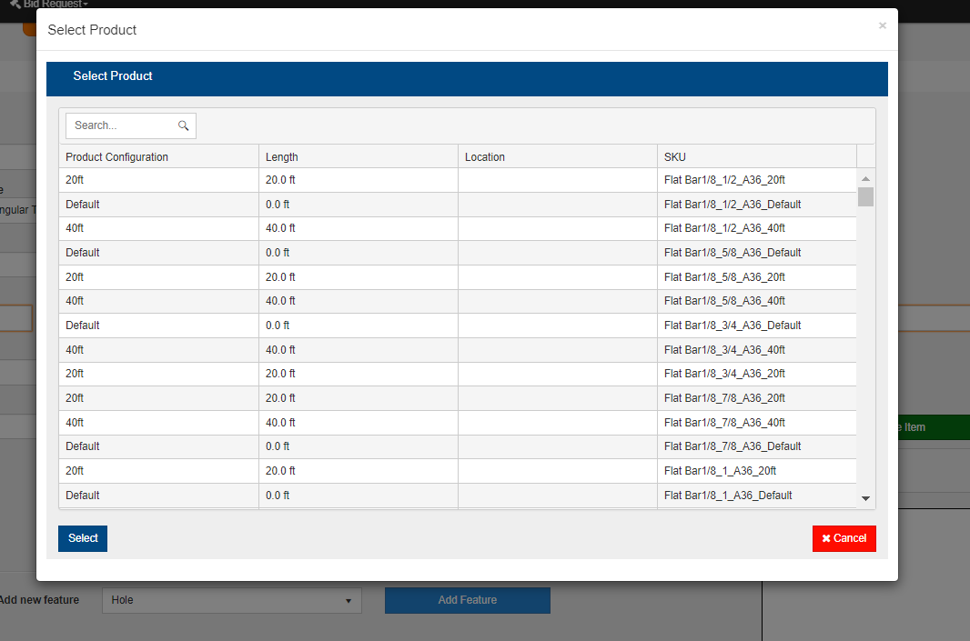

- Bug Fix: Copy Quote

  - This update addresses a critical issue where copying a quote would unintentionally remove certain information from the original quote, specifically the nest. We apologize for any inconvenience this may have caused and appreciate your patience as we worked to resolve this problem.

  - 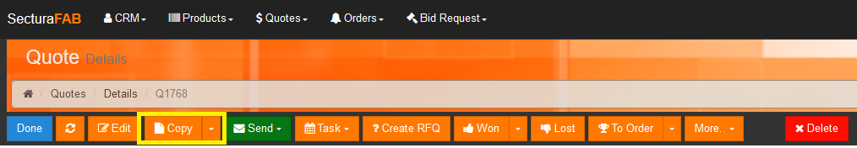

- Component Unit Costs Greater Than $999

  - This update introduces an improvement to the Component Cost field, enabling support for numbers greater than 999. With this enhancement, you can now accurately quote and estimate projects that involve higher-value components, ensuring precision and flexibility in your pricing calculations.

  - 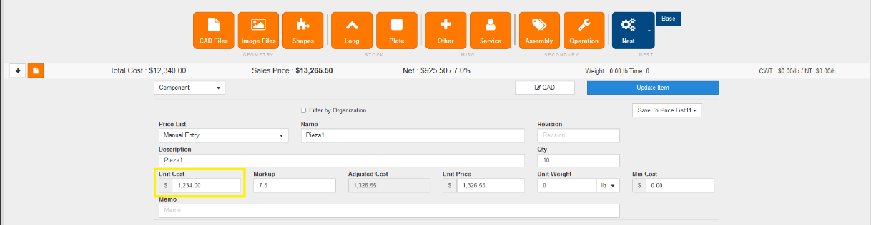

- Populating Tool Selection Dropdown Menu when Adding Operations

  - This release addresses a bug that affected the functionality of the dropdown menu for selecting a machining tool within an operation. Users may have experienced issues with the dropdown menu not working as expected.

  - 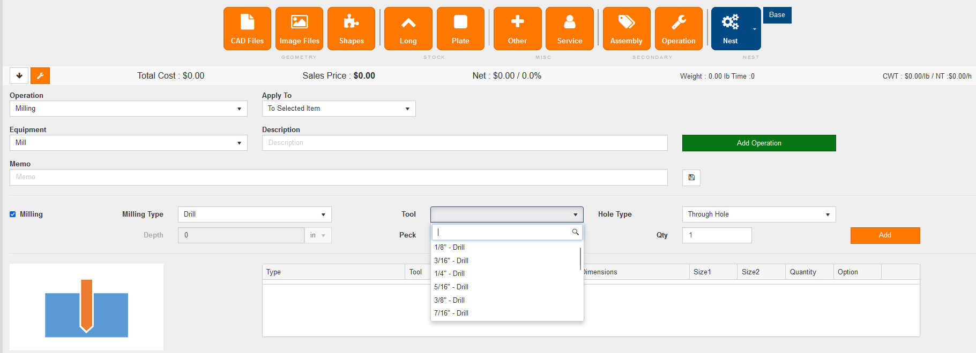

Conclusion: You will notice the updated software version 2023.06.13.4 automatically so you can immediately begin to take advantage of these enhancements. As always, we welcome your feedback and suggestions as we continue to improve our software to meet your evolving needs. For any questions or support please reach out to our Customer Success team via the email (help@secturasoft.com)
Thank you for your continued support.
Best regards,
SecturaSOFT Development Team

